Divvy.Apk

Table of Contents page no.

DIVVY……………………………………………………..3

Scan options……………………………………………4

Signer Certificate……………………………………..4

Permission……………………………………………….5

Certificate Analysis…………………………………..5

Manifest Analysis……………………………………..6

Jadax………………………………………………………7

Conclusion……………………………………………….8

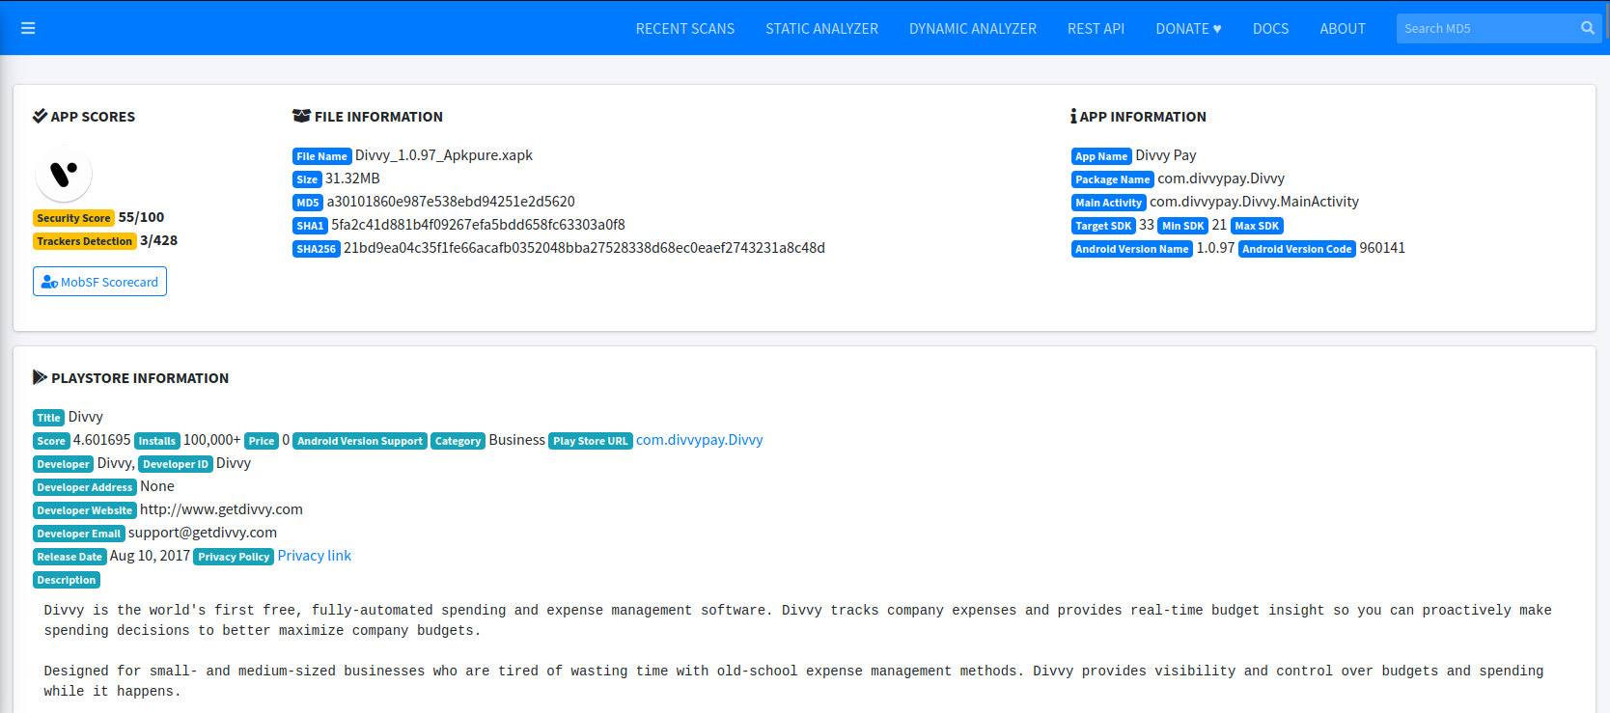Divvy Apk

Divvy is the world’s first free, fully automated spending and expense management software. Divvy tracks company expenses and provides real-time budget insight so you can proactively make spending decisions to better maximize company budgets.

Designed for small- and medium-sized businesses who are tired of wasting time with old-school expense management methods. Divvy provideds visibility and control over budgets and spending while it happens.

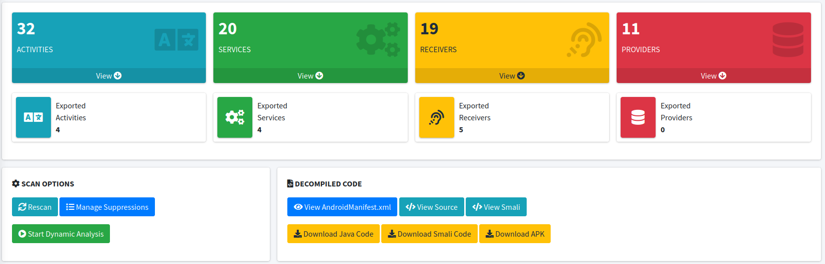Scan options

Here, we can see that we have scan that we can see that in the above figure there are 32 activities, 20 services, 19 receivers, 11 providers.

Signer certificate

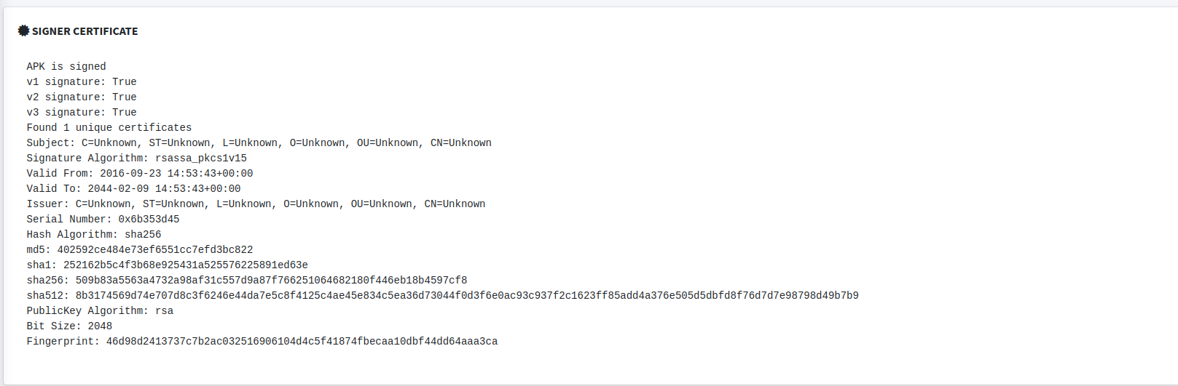

Here, we can see that there is verified signature that this is verified app and can be updated in play store.

permission

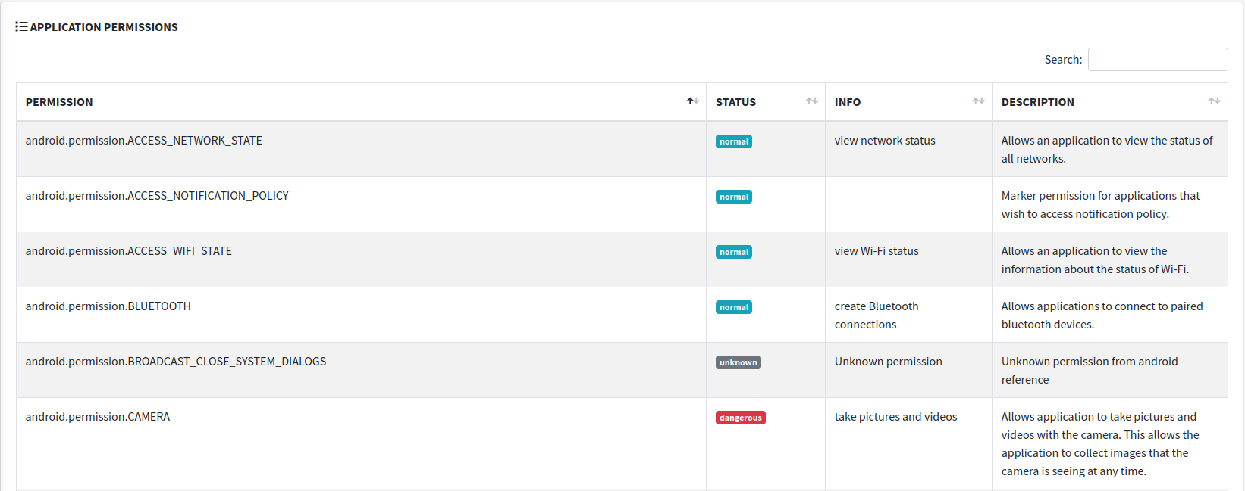

Here, we can see that there is permission, status, info and Description So, at first we have see that there are normal status that means this is no dangerous and we can the dangerous in the camera permission is dangerous i.e. in info we can see that they can take picture and Allow this application to take pictures and videos with the camera. And this allows the application to collect images that the camera is seeing at the time.

Certificate analysis

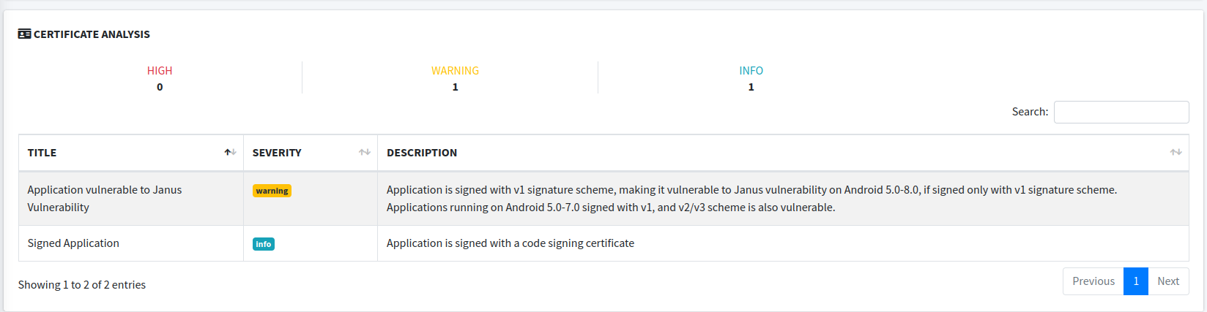

Here, we can see that there is Application is signed with v1 signature scheme, making it vulnerable to janus vulnerability on Android 5.0-8.0, if signed only with v1 signature scheme. Application running on Android 5.0-7.0, signed with v1, and v2/v3 scheme is also vulnerable.

Manifest analysis

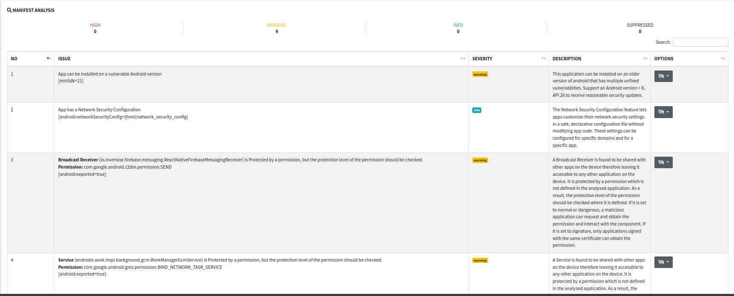

Here, we can see that there is 9 warning and that can vulnerable so, we can try to exploit them and we can stay safe by disabling this features.

jdax

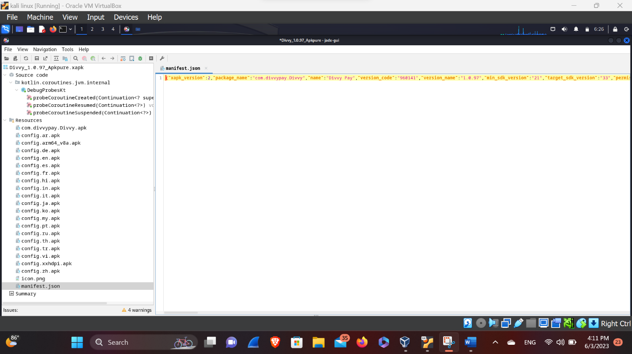

Here, we can analysis that what there is the issue by checking the code and we can see this by manifest.json there we can see the permission what the permission are given to this app we can see that there in the above picture we can see that there is permission of the camera that may takes the personal photo of ours let’s not to give the permission.

Conclusion

So, here let’s try not to allow the permission that an app may take an advantage of the malicious issue. So, this app may contain the permission of the camera that can be used to steal our photos and videos. So, we have to be aware of that.